5 Flex-Box Product Page

# The Select Options Dropdown

Creating this dropdown might seem a bit in-depth, but really there is not too much to it, and it should not give you any nightmares just thinking about attempting it.

We will be putting this select dropdown widget inside of a navigation. We can call this navigation anything we want but for now we will just be giving it a class of product-filter, since that is what it will be doing.

**The HTML**

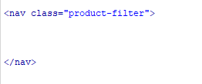

Next thing that we will be doing is to give it a heading. This would reflect what we wanted to sell. I just put “Watches” in for the heading, but of course you can use anything here that you want. Place this h1 above the navigation section.

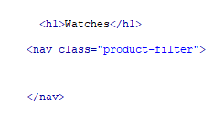

The next thing that we will specify inside of the navigation, is our select widget, we will give this the class name of “sort.”

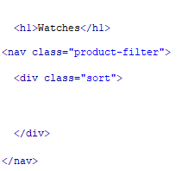

Inside of the div “sort” which is our select widget, we are going to have two dropdown options. We will put each of these dropdown options in their own divs, and give these two the class with the name of “collection-sort”

Each drop down will consist of a label, so we know what we are selecting and then the select-option, To create this, we will be putting the option tag with the value inside of a tag named select.

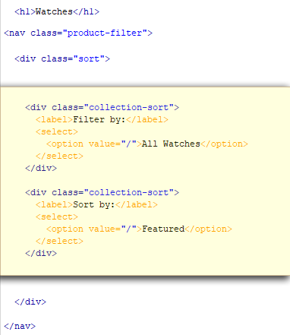

**The CSS**

Since, in the HTML, we placed this entire thing into the navigation, which we named “product-filter”, we will use that to be our flex element. So, we will set the display of product-filter to flex.

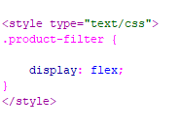

## The H1 tag

We are going to start by giving it a flex-grow value of 1.



**Setting the .sort div to flex**

If you look at your html, you will see that we placed our two div options into another div with a class name of .sort. We can nest our flex containers, which is just what we are doing with sort, this is because we will set sort to be displayed as flex, inside of the product-filter div that we have already designated as a flex container.

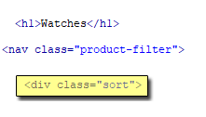

**The CSS for the .sort**



**Setting the .collection-sort div**

We are giving our drop-down options to display as flex, yes this is yet another flex container to be placed inside of the outer two containers. Then we want the labels of Filter by: and Sort by: to sit on top of the two dropdowns, so we set this container direction to be column. I also added a bit of padding so that the two widgets have a tiny bit of space between them.

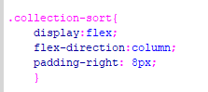

When we save, and run it in a browser, you should have this:

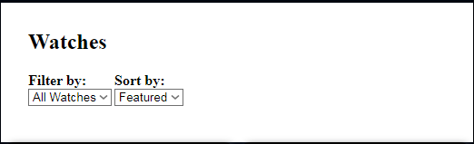

# The Products Layout